Nature is made of everything we see around us – trees, flowers, plants, animals, sky, mountains, forests and more. Human beings depend on nature to stay alive. Nature helps us breathe, gives us food, water, shelter, medicines, and clothes. We find many colors in nature which make the Earth beautiful.

Animals, fish and insects also get their food and shelter from nature. Different trees grow up due to sunlight and water provided by nature. Humans should stop causing harm to the elements of nature for their needs. Nature is very important to maintain the growth and balance of life on earth.

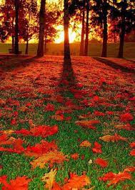 Nature includes living and non-living components that together make life on Earth possible. Some forms of nature can be seen through the lush green forests, the vast sky above us, the oceans without an end, the mountains standing tall and so on. Nature nourishes the survival needs of plants, animals and humans alike. It provides the essential components of oxygen, sunlight, soil and water.

## Nature is the best remedy for all problems over the word. Nature is an inspirational figure for various writers, novelists. We often heard that spending time in nature can freshen up our mind and body. Nature is the reason for living entities are surviving on earth. Nature is beneficial in all ways. Nature is the best remedy for all problems over the word. Nature is an inspirational figure for various writers, novelists. We often heard that spending time in nature can freshen up our mind and body. Nature is the reason for living entities are surviving on earth. Nature is beneficial in all ways.

